‘Being loved into life’ Lent Course 2025

Session 2: The Holy Spirit in prayer.

Talk:

So, last time we began to explore the reality of the work of the Holy Spirit within the life of a believer. And what I hope you picked up was the very ubiquity, the constant initiative and action of the Holy Spirit – all of the time – in drawing us to God, in transforming us to be more like Jesus (really) – if we let him, if pay attention to the action of the Holy Spirit who is already within us.

The theme that we’ll be exploring this evening, is the role of the Holy Spirit in prayer. So, let’s begin with some definitions; when I talk about ‘prayer’ what do I actually mean? Is prayer the ‘God bless Mummy, God bless Daddy’ of our childhoods’? Well yes, it is – but prayer is bigger than that. Is prayer our intercessions in church – or words of fervent longing for a car parking space? Yes, that’s prayer too – but again, prayer is more, is much bigger (more substantial) even than that. This evening I want to suggest that ‘prayer’ is our lived relationship with God, accomplished under the influence of the Holy Spirit. This is prayer.

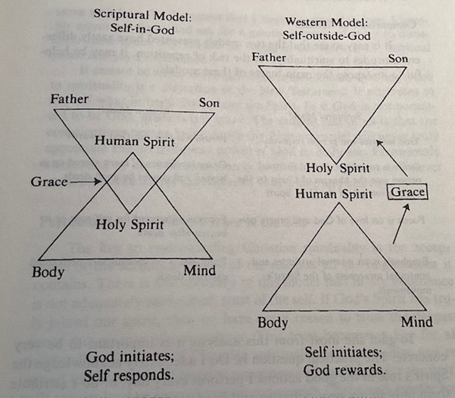Remember again the model of ‘what it means to be a Christian’ that we explored last week; the ‘Self-in God model’ as opposed the ‘self-outside God model’?

In the ‘self-outside God’ model (which is the understanding that many of us have been traditionally taught), prayer is what I do. It’s the script, to God, that I compose. It’s my ‘raising of my heart and mind to God’ through my own effort. Prayer is ‘words thrown to the sky’ – and if I get them right, God will reward me.

But, what if this traditional understanding of prayer is a pale imitation of what prayer truly is? What if it almost misses the whole point? As, it neglects the spectacular change, and transformation brought about by the coming of Jesus and the giving of the gift ‘of the Spirit of God’, in the lives of everyone who believes? Well, that’s where the ‘Self-in-God’ model comes in.

For if the ‘Self-in God’ model more clearly, more accurately, reveals what is truly going on, then we have to change our ideas about the nature of prayer entirely! For what if prayer, ‘isn’t what I do to God’? What if prayer is instead what the Holy Spirit elicits from me, and within me, which in turn, forms my relationship with God? God does this!

And d’you know what? We see this prayer (as an action of the Holy Spirit) bursting from Jesus’ heart all the time in the New Testament:

*At that time Jesus, full of joy through the Holy Spirit, said, ‘I praise you, Father, Lord of heaven and earth, because you have hidden these things from the wise and learned, and revealed them to little children. Yes, Father, for this is what you were pleased to do. (Luke 10:21).*

And it was the Apostle Paul (no less) who highlighted the centrality of the role of the Holy Spirit in prayer in his Epistle to the Romans – presenting clearly the inner dynamic of our union with Christ, through his Spirit, when it comes to prayer:

***26****In the same way, the Spirit helps us in our weakness. We do not know what we ought to pray for, but the Spirit himself intercedes for us through wordless groans.****27****And he who searches our hearts knows the mind of the Spirit, because the Spirit intercedes for God’s people in accordance with the will of God. (Romans 8:26-27).*

And why is this so important? Well, it means that the Holy Spirit is far more dynamically active in our lives, and in the lives of everyone of who believe, than we ever thought before. If you’re anything like me, you’d always assumed that the Holy Spirit, was kind of ‘kept for best’, would be active simply when you were doing courageous ‘holy things’ – the Holy Spirit was about ‘Miracles’ – rather than ‘Monday mornings’! But what if this simply isn’t the case at all! What if the infinite, all powerful Holy Spirit, is at work in our lives all the time, as we even do the most basic things, such to pray for our parking space?!

Well, if this is true (and I believe is!), do you know what this means? It means that - there is just so much more! So much more that we can know of God, some much more that we can experience of God – if it is God who is already at work within me, initiating even my most fundamental desire for God and my yearning to do what is good and right. For this God is already here, within you and me, (and not lost in some star-lit heaven), then God is closer to me than I ever dreamt possible!

And from the pages of the New Testament, we even have a good idea of much of what the Holy Spirit longs to do through you and me. Remember that I defined ‘prayer’, not just as words, but as our lived relationship with God, accomplished under the influence of the Holy Spirit. But, to do what?

First, as God is the source of love, the Holy Spirit longs to empower us to love. It was the Apostle John who wrote:

***7****My dear people, let us love one another, since love comes from God and everyone who loves is begotten by God and knows God. Anyone who fails to love can never have known God, because God is love…No one has ever seen God; but as long as we love one another God will live in us and his love will be complete in us because he lets us share his Spirit (1 John 4:7-8, 12-13 New Jerusalem Version).*

The Apostle Paul echoes John both in asserting that all love comes from God *“…the love God has poured into our hearts by the Holy Spirit which has been given us.” (Romans 5:5)* But then he underlines the impact of this love,how it is the Holy Spirit who then brings us into a hither to unknown intimate love relationship with God the Father:

*For those who are led by the Spirit of God are the children of God. The Spirit you received does not make you slaves, so that you live in fear again; rather, the Spirit you received brought about your adoption to sonship. And by him we cry, ‘Abba, Father.’  The Spirit himself testifies with our spirit that we are God’s children. (Romans 8:14-16).*

And this Spirit-enabled love of God, then overflows into love of others and of ourselves. As the Paul writes to the church in Ephesus:

*Be completely humble and gentle; be patient, bearing with one another in love. Make every effort to keep the unity of the Spirit through the bond of peace. There is one body and one Spirit, just as you were called to one hope when you were called; one Lord, one faith, one baptism;* (Ephesians 4:2-5).

If, firstly, the Holy Spirit seeks to enable us to love, then secondly, the Holy Spirit seeks to guide us in the best ways to express this love. It was Jesus, who said of the promised Holy Spirit:

*‘All this I have spoken while still with you.**But the Advocate, the Holy Spirit, whom the Father will send in my name, will teach you all things and will remind you of everything I have said to you.* (John 14:25-26)

It is the Holy Spirit who enlightens and guides us, so that as the Apostle Paul told the Church in Galatia:

*“Let me put it like this: if you are guided by the Spirit you will be in no danger of yielding to self-indulgence, since self-indulgence is the opposite of the Spirit, the Spirit is totally against such a thing, and precisely because the two are so opposed that you do not carry out your good intentions.* (Galatians 5:16-17)

And St Paul concludes this discussion with these simple words: “Since the Spirit is our life, let us be directed by the Spirit.” (Galatians 5:25).

And boy! Once sought, the Holy Spirit was not backwards in giving guidance as the early Church discovered, as recorded in the book of Acts:

“It seemed good to the Holy Spirit, and to us, not to burden you with anything beyond the following requirements: You are to abstain from food sacrificed to idols, from blood, from the meat of strangled animals and from sexual immorality. You will do well to avoid these things.” (Acts 15:28-29)

So, if the Holy Spirit empowers us to love, then this same Holy Spirit guides us in how to express this love, the, thirdly (and finally) the Holy Spirit is our source of strength to actually love and serve both God and others. It is the Holy Spirit who can enable you and me to work zealously both within the Christian Community and in the wider world. Our experience can be the same as the Apostle Paul who wrote:

*“There is a variety of gifts but always the same Spirit; there are sorts of service to be done, but always the same Lord; working in all sots of different ways in different people, it is the same God who is working in all of them. He particular way in which the Spirit is given to each person is for a good purpose. One may have the gift of preaching with wisdom given him by the Spirit; another may have the gift of instruction given him by the same Spirit; and another the gift of faith given by the same Spirit; another the gift of healing, through this one Spirit; one, power of miracles; another, prophecy; another the gift of recognising spirits; another the gift of tongues and another the ability to interpret them. All these are the work of the one and the same Spirit, who distributes gifts to different people just as he chooses.* (1 Corinthians 12:4-11).

And why? Why should the Holy Spirit seek to do all of this through fragile and broken you and I? Well, because the Holy Spirit, the Spirit of Jesus, wants us to become more like Jesus (really). That’s the end-goal here! We are not here to build a religious institution, to be a ‘miracle show’, to use God to get what we want or to show those ‘out there’ how much better we are than them. No – all of this Spirit, his Spirit, is given is to accomplish what Jesus said he wanted to accomplish through all of his disciples, all along:

*But you will receive power when the Holy Spirit comes on you; and you will be my witnesses in Jerusalem, and in all Judea and Samaria, and to the ends of the earth.’* (Acts 1:8)

In conclusion, my friends, what has struck me, as I have prepared tonight’s talk is the sheer ubiquity of the Holy Spirit! How, for the believer, the Holy Spirit is everywhere and does almost everything for us. From drawing us to Christ, enabling us to pray, facilitating a new and dynamic intimacy with God, empowering us to love, then guiding us who to love, and then strengthening to love both individually and as a community of faith.

Wouldn’t it be amazing if we could simply appreciate the Holy Spirit doing this within us? Wouldn’t it be so encouraging to notice the Holy Spirit at work? Who knows we might even be able to join in! Well, how to do this is what we are going to be exploring later in our course.